SKY SPIRIT NETWORK

AGENT GUIDE

Sharing Light, Love & Abundance Through Channelled Art

WELCOME TO THE SKY SPIRIT NETWORK AGENT FAMILY
Welcome, and thank you for joining the Sky Spirit Network Agent Scheme. By becoming an agent, you’re not just promoting beautiful artwork, you can also help to spread healing energy, light and love across the world.
I work as a landscape and ‘general’ artist and illustrator. I also work in the ‘visionary’ art genre, and this type of art generates the majority of my sales. Every astral painting I create is channelled through connection with angelic energies, spirit guides and elemental forces. These artworks, both as original paintings and prints, carry specific healing frequencies designed to support spiritual growth, meditation, and transformation.
Although I love painting and creating, I’m rubbish at marketing. Over the years I’ve been working as an artist, outside of traditional ‘bricks and mortar’ galleries, I’ve found that most of my sales come from people sharing images of my work with others, over social media for example. Recently, I decided that if this is the case, surely it makes sense that these people should share in the revenue? After all, they’re doing the work of an online gallery? This is how the idea for the Sky Spirit Agent Network was conceived.
As an agent, you have the opportunity to share images of my work with your community, both on an offline, while earning generous commissions. This guide will walk you through everything you need to know to succeed as a Sky Spirit Network agent.
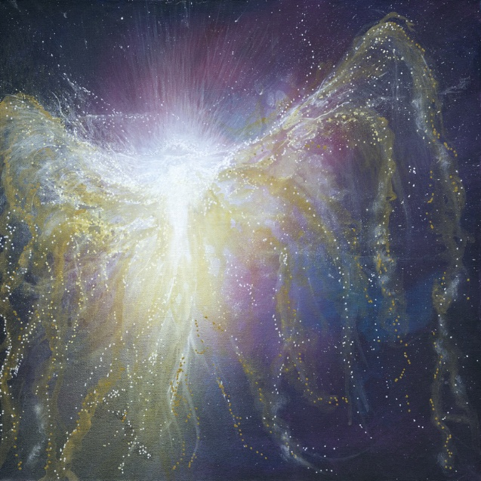

TABLE OF CONTENTS
- What is the Sky Spirit Network Agent Scheme?
- Who Can Become an Agent?
- How the Agent Scheme Works
- Commission Structure
- Getting Started: Your Affiliate Portal
- Navigating Your Affiliate Portal (Visual Walkthrough)
- Creating & Sharing Content
- Marketing Tools & Resources
- Social Media Best Practices
- Tracking Your Referrals
- Commission Payments
- Do’s and Don’ts for Agents
- Tips for Success

1. WHAT IS THE SKY SPIRIT NETWORK AGENT SCHEME?
The Sky Spirit Network Agent Scheme is an affiliate marketing program that rewards you for sharing my artwork with your network. When someone purchases an original painting or print through your unique referral link, you earn a commission.
I created this scheme because many people already share my images organically. I believe that if your efforts lead to sales, you deserve to be generously rewarded and share in the abundance.
The mission: To spread the message of light and love while creating a community of agents who are passionate about spiritual art and healing energy.

2. WHO CAN BECOME AN AGENT?
Anyone with a passion for spiritual growth, healing and visionary art can become a Sky Spirit Network agent. You might be:
- A spiritual practitioner (yoga teacher, healer, meditation guide)
- An art enthusiast or collector
- Someone with a social media following interested in metaphysical topics
- A friend or supporter who resonates with the energy of the artwork
- Anyone who feels called to share my channelled creations
No experience required. Whether you’re new to affiliate marketing or a seasoned promoter, this guide will help you succeed.

3. HOW THE AGENT SCHEME WORKS
The Sky Spirit Network Agent Scheme operates on a simple referral model:
- You receive a unique referral link when you join the program for free
- You share this link with your audience through social media, email, blogs, videos, or any creative method (do it as often or as little as you please – there are no obligations!)
- Customers click your link and visit skyspirit.co.uk
- When they make a purchase, the sale is tracked to your account
- You earn commission on every sale attributed to your link
Important: Cookies last for 30 days, meaning any purchase made within 30 days of someone clicking your link will be attributed to you—even if they don’t buy immediately.

4. COMMISSION STRUCTURE
I offer generous commission rates:
- 33% commission on original artwork (paintings priced £200–£2000)
- 15% commission on prints (priced under £20 to over £100)
Focus Areas: While you can promote all products, I encourage agents to focus primarily on original artwork and prints, as these are the best sellers from the website.
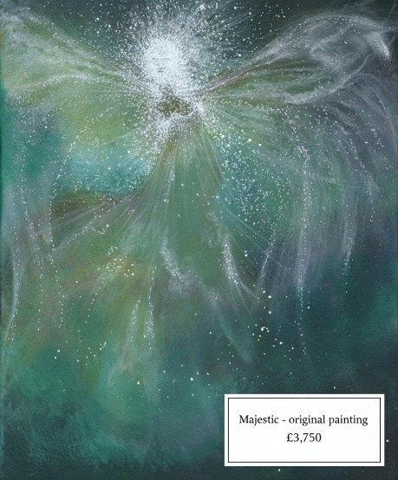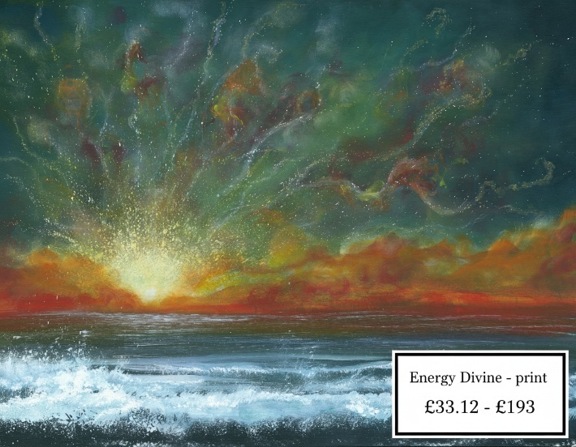

5. GETTING STARTED: YOUR AFFILIATE PORTAL
Once you’re enrolled in the Agent Scheme, you’ll have access to your personal Affiliate Portal. This is your central hub for:
- Accessing your unique referral link for the website
- Accessing marketing materials (images, videos, documents)
- Tracking your referrals and sales
- Viewing your commission earnings
- Creating product-specific links
Tip: Key Feature: Link Generator
Rather than sharing your unique referral link that leads customers to the website home page so that they can browse the entire site, you can create a unique link to any specific painting or print by: 1. Copying the product URL directly from skyspirit.co.uk 2. Pasting it into the link generator on the Marketing Tools page of your portal 3. Using the generated link in your promotions. You’ll find out how to do this in the next section.

6. SIGNING UP AS AN AGENT AND NAVIGATING YOUR AFFILIATE PORTAL (VISUAL WALKTHROUGH)
Let me walk you through the sign up process and your portal so you feel confident using all the tools available to you. If you’ve already signed up, you can skip the first part!

Signing Up
1 Click ‘Become an Agent’ on the website home page (skyspirit.co.uk)
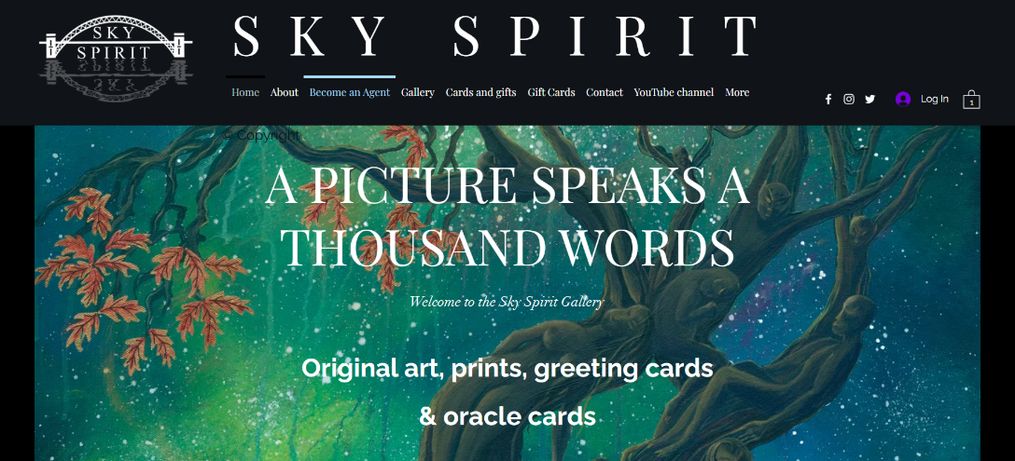
2 Read the information about the agent scheme and click one of the purple buttons to join.
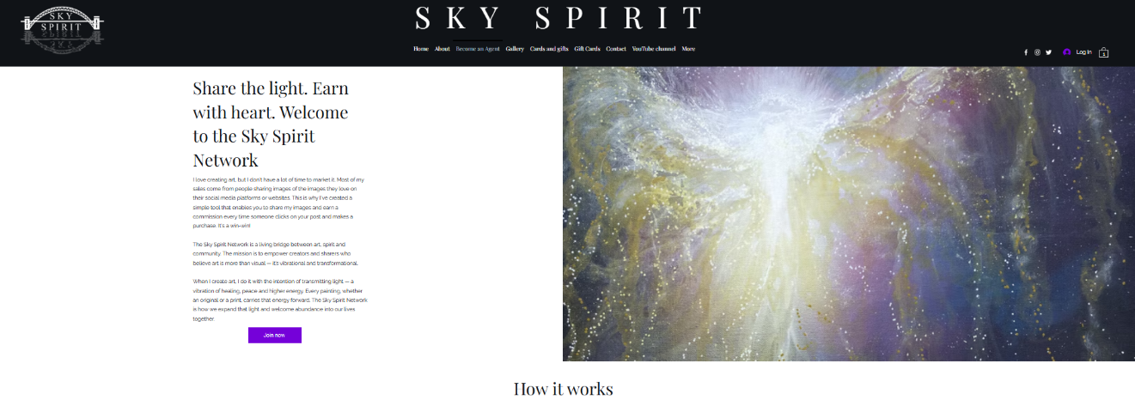
3 Enter your name, email address and create a password. Then click the ‘Create Account’ button. Alternatively, you can join using your Google or Facebook account if you prefer.
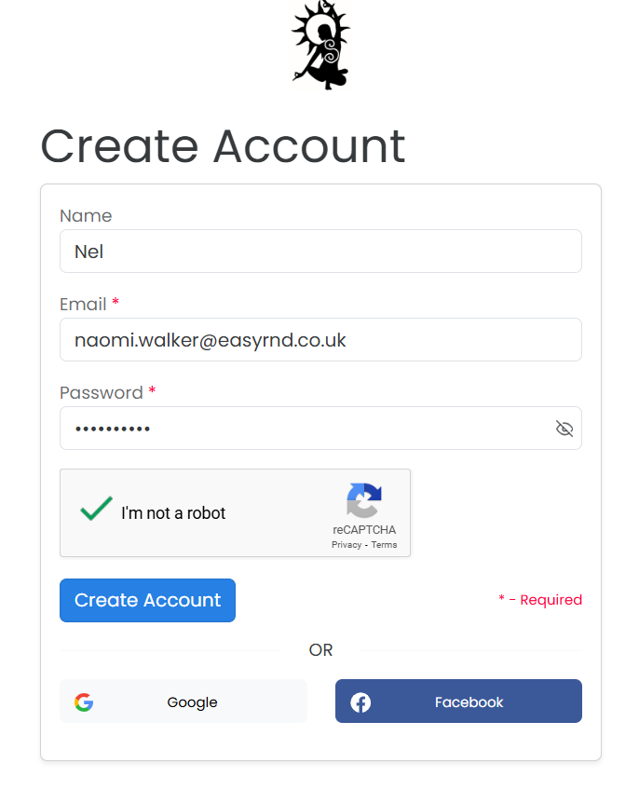
4 You’ll see a notification telling you that an account verification email has been sent to the email address you provided. Now, go and check your email.
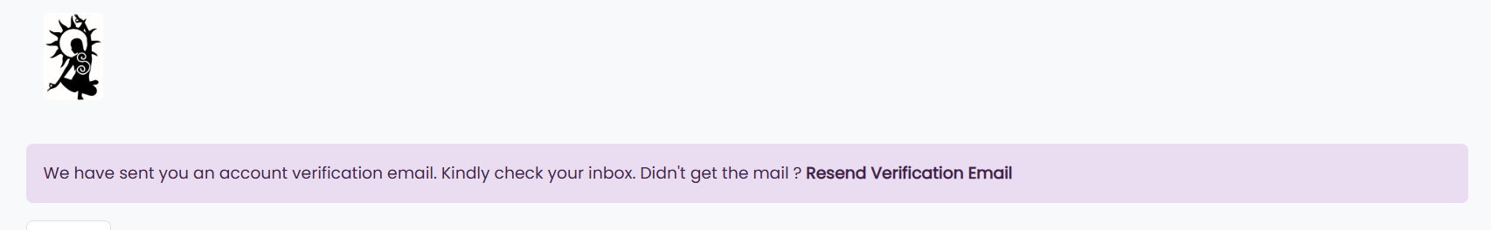
5 Find the email and click on the link or the button to verify.
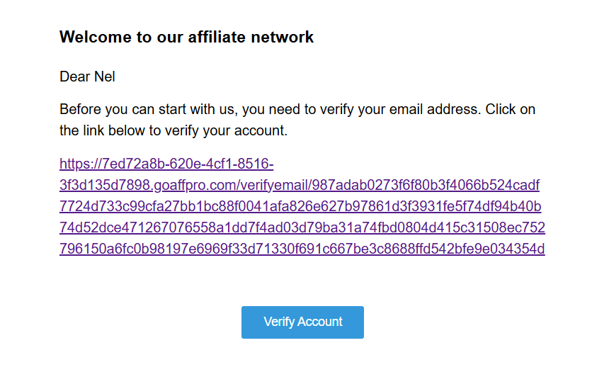
6 You can then return to the dashboard
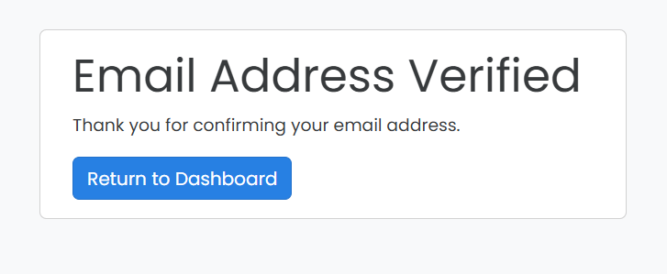

Logging In
When you’re approved as an agent, you can log into your Affiliate Portal on the skyspirit.co.uk home page. Use the purple button. It looks like this on a mobile device:
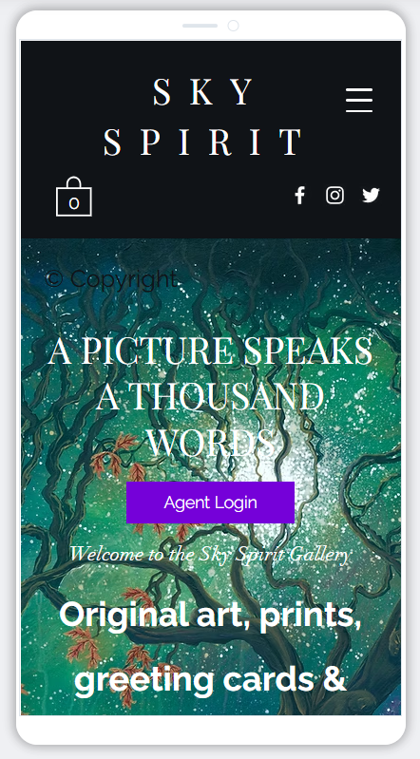
And it looks like this on a desktop/laptop/tablet:
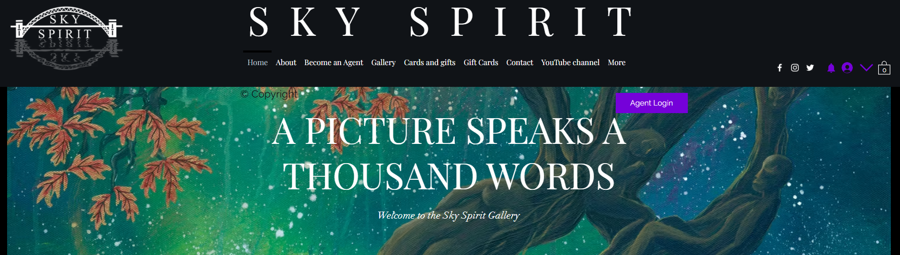

Your Dashboard
When you log into your Affiliate Portal, the first page you see is your dashboard. This is your home base. Here you can see at a glance how your referrals are performing and how much commission you’ve earned.
It also gives you your unique referral link to the home page of skyspirit.co.uk. This is what you share, alongside any content such as images or videos. When people click on your link to access the site, if they then go onto make a purchase within 30 days, you’ll receive a commission. You can copy the unique referral link and paste it or directly share it using the tool buttons – see highlight.
There is also a coupon code that you can provide as an incentive for people to buy. You might use it like this: ‘Click the link to buy and use code NEL at the checkout to get 10% off’
The 15% commission figure shows the generic commission across the entire site. Original paintings are set at a higher commission rate.
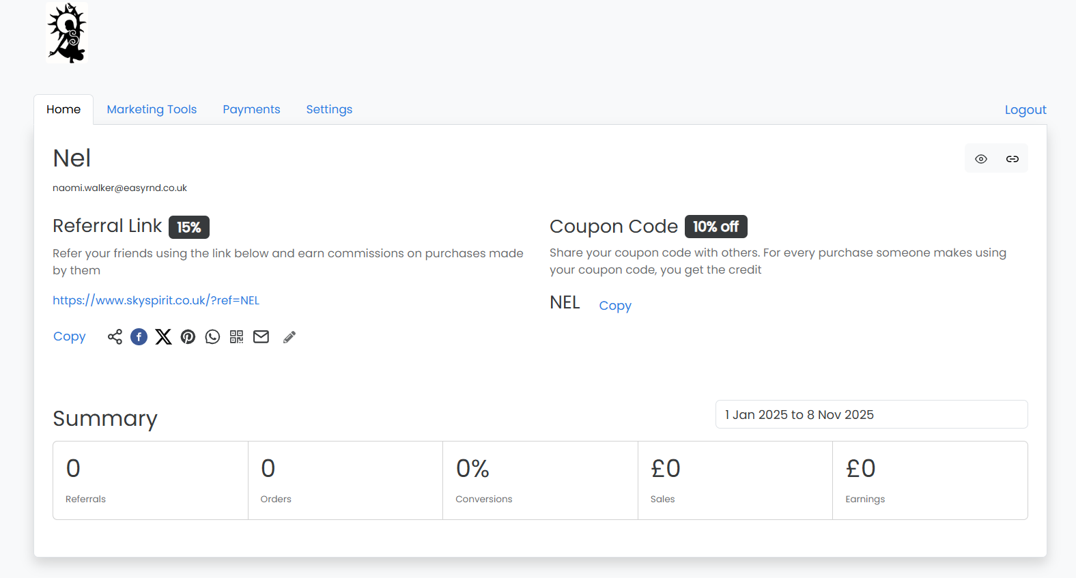

Accessing Marketing Tools
This is where you’ll find all the images, videos, and suggested posts I’ve created for you to use. You are also more than welcome to use your own creativity to create content to share alongside your link.
To access the Marketing Tools, click on the tab:
This is what your Marketing Tools page looks like. Let’s now have a closer look at some of those tools.
Link generator
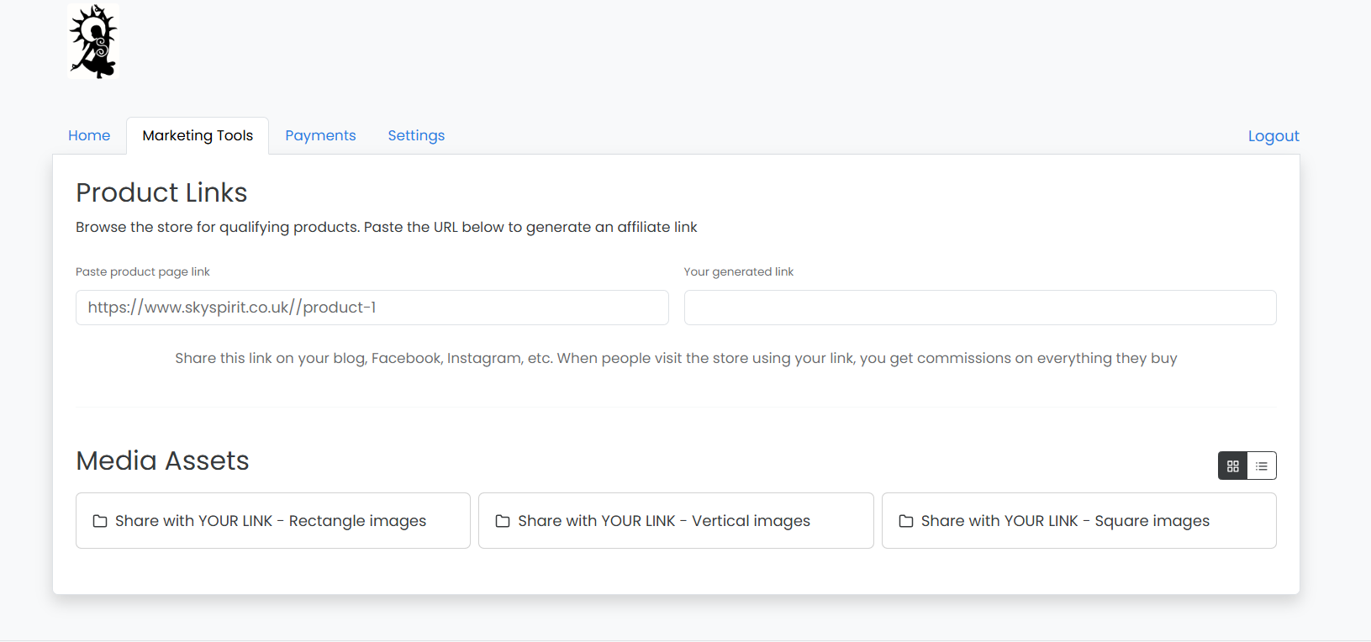

Using the Link Generator
Whereas you have a unique referral link that leads to the home page of skyspirit.co.uk. This tool can make links that lead to specific products – particularly useful when you want to promote an original painting or a painting being created live in a studio livestream.
Step-by-step: 1. Go to skyspirit.co.uk and find the painting or print you want to promote 2. Copy the URL from your browser’s address bar 3. Paste it into the link generator in your portal (shown by the red arrow) 4. Click “Generate” 5. Copy your unique link and use it in your content.
Media Assets
The Media Assets section on the Marketing Tools page is where you’ll find shareable content that I’ve already created for you. You can also find documentation, such as a copy of this guide, and other useful information here such as demonstration videos showing how the agent scheme works and demonstrations on how to share content on different platforms.
Below is a screenshot of some of the square shareable images I’ve created. Square images will display well on most social media platforms. Each image contains a call-to-action that prompts the viewer to ‘click the link’. When you share an image, make sure you add your unique referral link as the link for people to click.

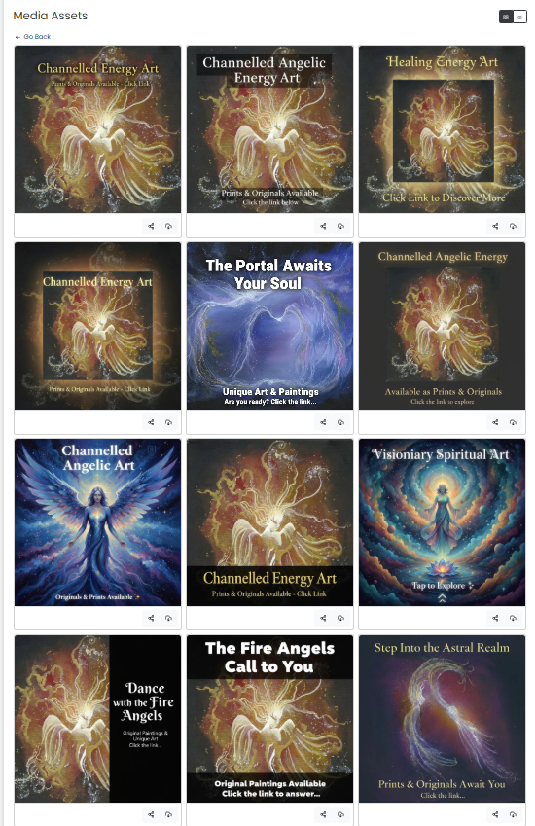
To download one of the media assets, simply click on the download button and save it to your device (or you can right-click on the image and select ‘save image’)
Download button

Tracking Your Performance
At the bottom of the dashboard home page, you can track your performance. Check this regularly to see which content is working best and which products resonate most with your audience.
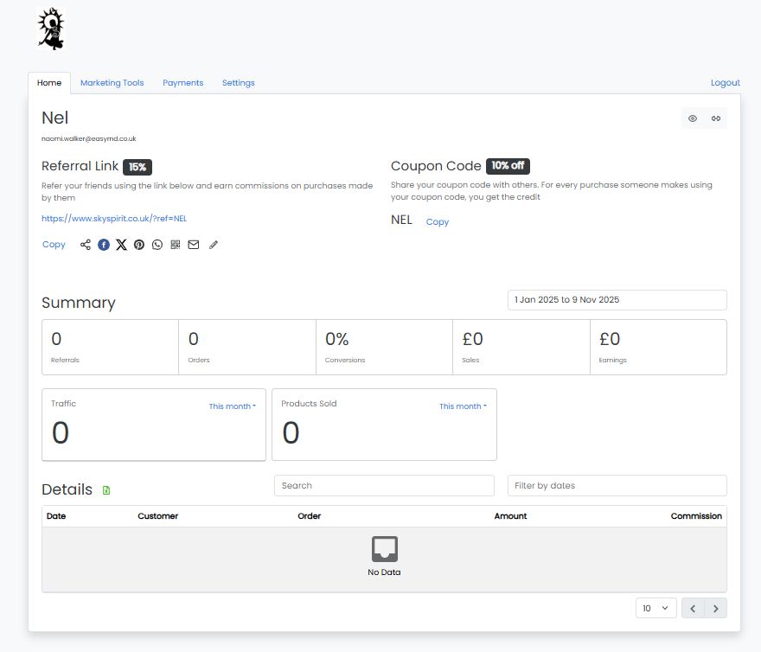

7. CREATING & SHARING CONTENT
Great content is the heart of successful marketing. The more authentic and engaging your content, the more likely people are to connect with the artwork and make a purchase.

Content Ideas:
Social Media Posts - Share images of paintings that resonate with you, along with your personal connection to the piece. Or, post about the energy frequencies and spiritual themes in the artwork, you can find the information about the energy frequencies in the product descriptions on skyspirit.co.uk. Create carousel posts showing multiple pieces or close-up details. See section 9 for more detailed information about platform-specific ways to share your link.
Video Content - Film yourself talking about a specific painting and why it speaks to you. Share my YouTube livestreams where I create art and activate spirit and angel portals live. Or share my recorded videos about individual paintings. Create short-form videos (Reels, TikToks) featuring the artwork with spiritual music or affirmations.
Blog Posts or Articles - Write about the art: Review specific pieces and their energetic qualities. Share your personal spiritual journey and how the artwork supports it
Email Newsletters - Send monthly updates featuring new paintings or prints. Share stories about the artwork.
Think Outside the Box - Share links in spiritual Facebook groups or forums (where permitted) - Include links in your email signature, mention the artwork during yoga classes, healing sessions or workshops, create Pinterest boards featuring the art etc etc. Be creative, be imaginative.
IMPORTANT! Always include your unique referral link with every piece of content you share. It’s the ONLY way that sales can be attributed to you.

8. MARKETING TOOLS & RESOURCES
I provide some ready-to-use marketing materials to make promotion easy and effective. You can find these in the Media Assets section of the Marketing Tools page.

Image Formats Available:
- Square format – Ideal for Instagram feed posts and Facebook
- Vertical format – Perfect for Instagram Stories, Pinterest, and TikTok
- Rectangular format – Best for Facebook posts, LinkedIn, and Twitter/X
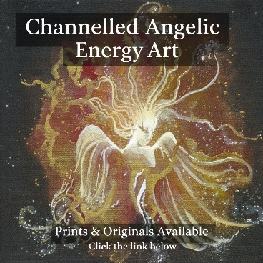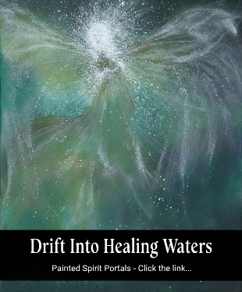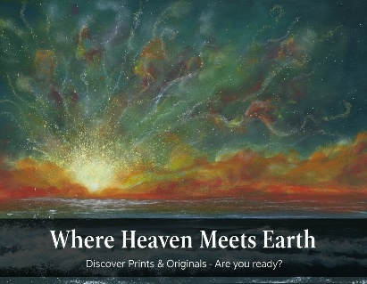

Video Content:
- YouTube livestreams of me creating channelled art
- YouTube videos of me painting or discussing specific paintings
- ASMR video recordings from YouTube
- All YouTube content can also be found on YouTube on the channel @skyspiritportal, an example video is shown below.

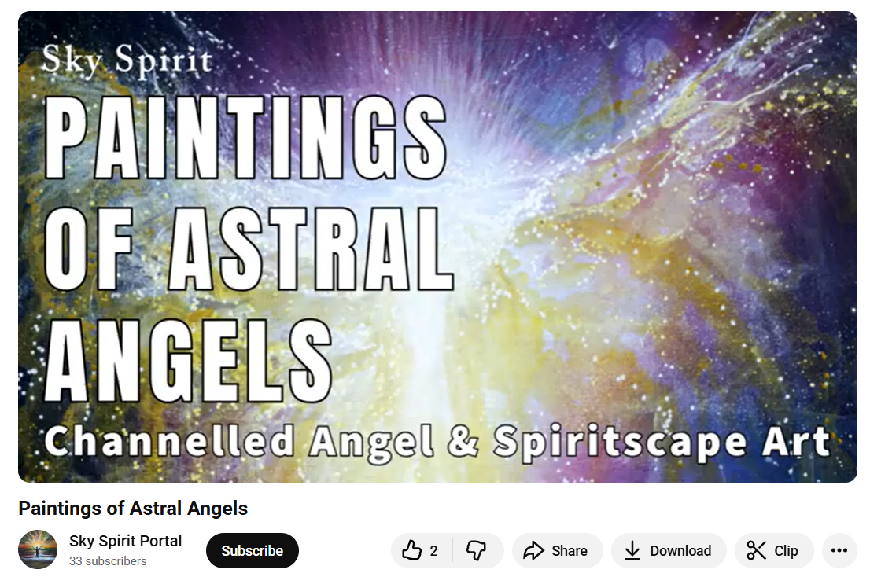

Suggested Social Media Posts:
- Pre-written posts that you can use as-is or customise
- Templates to inspire your own authentic content
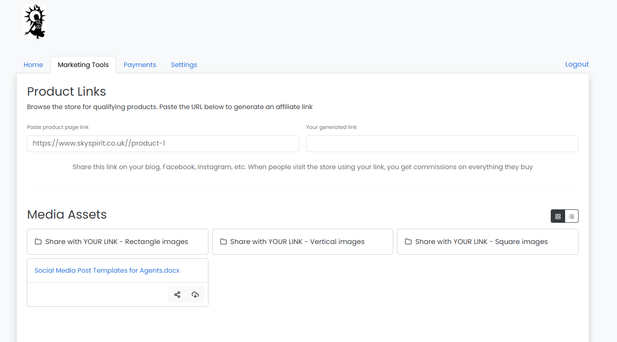Access all materials on the Marketing Tools page of your Affiliate Portal. Be sure to regularly check for updates to this guide (check version number to make sure you are following the latest guidance)

9. SOCIAL MEDIA BEST PRACTICES

Platform-Specific Tips:
Instagram - Use square or vertical images - Post consistently (3–5 times per week) - Use Stories to share behind-the-scenes content and livestream announcements - Use relevant hashtags: #spiritualart #angelart #healingart #visionaryart #channelledart.
You can share your links in normal posts on Instagram. Posts have the benefit of being available indefinitely, or until you delete them, but the links you type into them aren’t clickable. One way around this is to use a graphic that directs your audience to click on the link in your bio and then post your unique affiliate link there.
You can share clickable links on Instagram primarily through Instagram Stories using the link sticker. Both normal posts and stories clearly have their pros and cons, so I’d recommend that you use a mixture of both!
How to add a link to an Instagram Story (using a mobile phone)
- Create a new Story by tapping the plus sign or swiping right.
- Take or upload a photo or video.
- Tap the music sign to add music to your creation.
- Tap the sticker icon (the smiley face) in the top-right corner.
- Select the "LINK" sticker.
- Paste the URL you want to share. You can add alternative text to be displayed instead of the long link. For example, I’ve used ‘ENTER HERE’ tap "Done".
- Place the sticker on your Story so the artwork or video isn’t covered. You can tap to change its colour and customise the text.
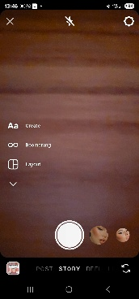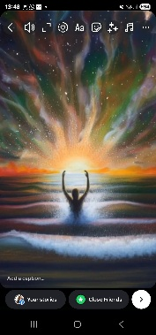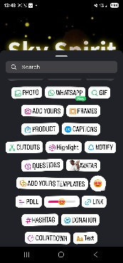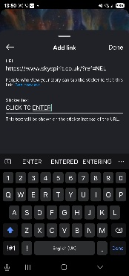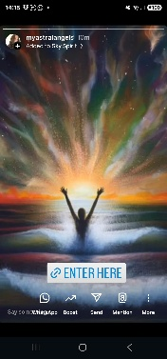
How to share a link through direct messages
- Copy the link you want to share.
- Open the Instagram app and tap the direct message icon in the top-right corner.
- Go to the chat with the person you want to send the link to.
- Paste the link into the text box and press send.
For posts and reels
- You can't add clickable links directly in a post's caption or on an image or video.
- The standard way to share a link for these formats is to tell your audience to "click the link in bio". There is a set of images in the Media Assets that include the call-to-action, ‘Click the link in the bio’ or similar specifically for this use.
- Be sure to include your unique affiliate link in your bio.

Facebook - Rectangular or square images work best - Share in relevant spiritual and art groups (with permission) - Go live or share my livestreams with your link - Engage with comments to build community.
How to share a link on Facebook
- Go to the "What's on your mind..." box at the top of your Facebook Feed.
- Paste the URL of the link you want to share.
- Add an image or wait for the link preview to generate an image, title and description.
- Add your own text or update to the post (Take a look at the social media post templates document in the Media Assets for inspiration).
- Click Post.
Tips for sharing links
- Place the link early: For a better user experience, try placing the link within the first couple of sentences so it's not hidden by the "see more" button.
- Highlight value: To encourage clicks, provide a clear reason for people to visit the link in your post's text. For example, you can include your unique discount code that offers people 10% off purchases.
Pinterest - Vertical images perform best - Create boards around themes: Angel Art, Healing Energy, Spiritual Decor - Pin consistently and link back to specific products.
YouTube – You can share my livestreams and video content from Youtube, along with your unique link. You can also create your own video reviews of my work or spiritual art narratives - Discuss the energy and meaning behind specific pieces.
TikTok - Use vertical video format - Create short, engaging videos with trending audio - Show the artwork with text overlays about its healing properties, spiritual energy, frequencies or more. (Take a look at the social media post templates document in the Media Assets for inspiration).
LinkedIn - Share the professional side: art as an investment, supporting independent artists, reviews of my work etc - Rectangular images work well.
Twitter/X - Share quick updates, new releases and livestream links - Use relevant hashtags and engage with the spiritual community.
In all cases, REMEMBER to ADD YOUR UNIQUE AFFILIATE LINK!!

10. TRACKING YOUR REFERRALS
Your Affiliate Portal provides detailed analytics so you can track:
- How many people clicked your links
- Which products are generating the most interest
- Sales attributed to your referrals
- Commission earned
Cookie Duration: 30 Days
When someone clicks your unique link, a cookie is placed in their browser for 30 days. Any purchase they make during that time will be attributed to you—even if they leave the site and return later.
Pro Tip: Share new links at least monthly to keep your referrals active and maximize your earning potential.

11. COMMISSION PAYMENTS
Payment Schedule: Commissions are paid monthly for sales made 30 days previously.
Why the 30-day delay? I offer customers a 30-day return window. This delay ensures that commission is only paid on completed sales (not on products that are returned and refunded).
Example: Sales made in January will be paid at the end of February. I know this might sound like a long wait, but given that I offer customers the chance to return items within 30 days, it’s the only way it can work for us all
Payment details and methods can be managed through your Affiliate Portal. It’s important that you have a PayPal account and you must add your Paypal details so your payment can be sent to you.

12. DO’S AND DON’TS FOR AGENTS

DO:
✓ Create your own content if you feel drawn to
✓ Share my YouTube livestreams where I create and activate spirit and angel portals live (make sure you include your unique link!)
✓ Share links to specific paintings or prints that call to you
✓ Use the link generator to create product-specific links from skyspirit.co.uk URLs
✓ Check that original paintings are still available before promoting them (they may have sold)
✓ Ensure your content aligns with our ethos of love, light and healing
✓ Contact me if in doubt about whether content is appropriate
✓ Spread the opportunity worldwide—prints and originals ship globally
✓ Think outside the box with creative ways to share your link
✓ Use the media assets provided on the Marketing Tools page
✓ Check for updates to this guide regularly (check the version number of the document you are using against the current version available in the Media Assets).

DON’T:
✗ Don’t use the generic skyspirit.co.uk URL—it’s not trackable, so you won’t earn commission
✗ Don’t share content that contradicts the brand’s message of love, light, and healing
✗ Don’t promote original paintings without checking they are still available
✗ Don’t forget to include your unique link in every post, video, or email

13. TIPS FOR SUCCESS
Build Trust & Authenticity
Share your genuine connection to the artwork. People buy from people they trust, so let your passion shine through.
Focus on the Energy
Highlight the healing frequencies, spiritual themes and channelled nature of the art. This is what makes this art unique.
Be Consistent
Regular posting keeps you visible. Aim to share content at least weekly, if not more often.
Engage with Your Audience
Respond to comments, answer questions and build a community around the art and its message.
Leverage Livestreams
My YouTube livestreams are powerful opportunities. When I create and activate angel and spirit portals live, viewers can purchase in real-time. Share these events with your link for a 33% commission on originals sold.
Use Analytics
Check your portal regularly to see what’s working. Double down on content and products that generate clicks and sales.
Collaborate & Share the Opportunity
Invite friends around the world to become agents too. The more people sharing the light, the greater the abundance for all.
Stay Aligned
Remember, you’re not just selling art—you’re facilitating healing and transformation. Stay connected to that higher purpose.

FINAL THOUGHTS
Thank you for being part of the Sky Spirit Network family. Your role as an agent is vital in spreading channelled art, healing energy and the message of love and light to souls around the world.
I created this agent scheme because I recognize that many of you already share my work out of genuine connection and passion. You deserve to be rewarded generously for your efforts.
Together, we can create a ripple of abundance, healing, and beauty across the globe.
If you have questions or need support, please reach out to me directly.
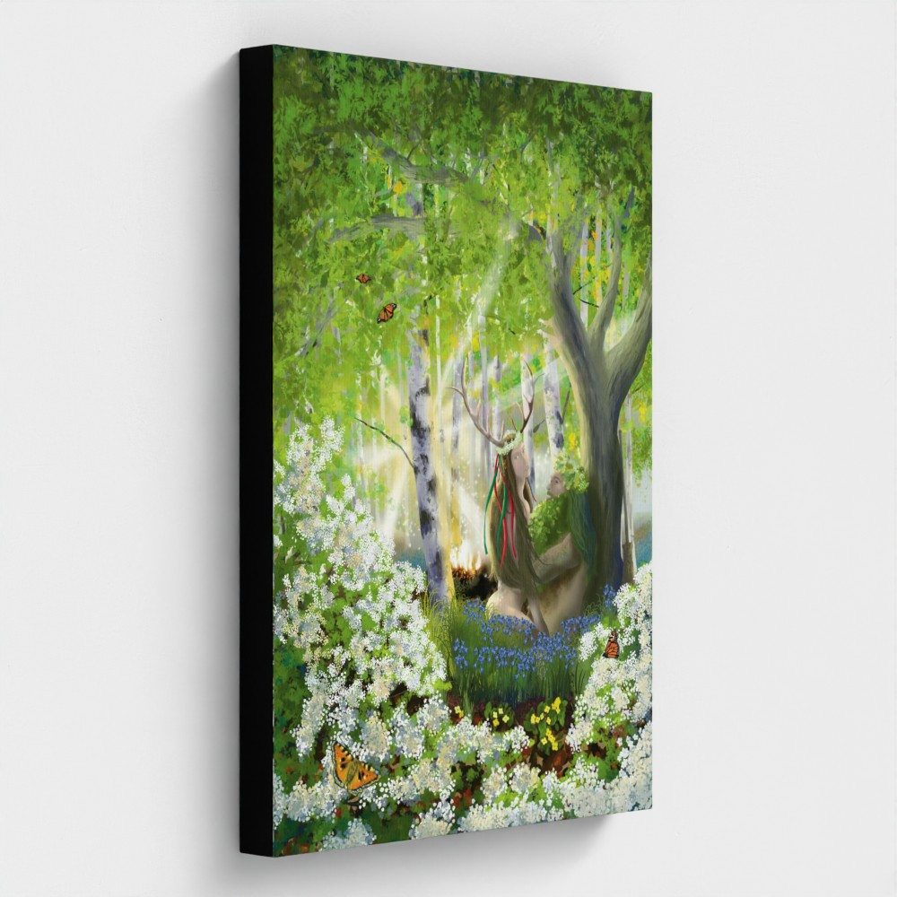

CONNECT WITH SKY SPIRIT NETWORK
Website: www.skyspirit.co.uk Email: Contact link at the bottom of your affiliate portal
YouTube: @skyspiritportal (for livestreams and art creation videos)
Social Media: Facebook | Instagram | LinkedIn | TikTok | X

